**SOUTHAMPTON SOLENT UNIVERSITY**

**BSc (Hons) Computing**

**Solent Student Discounts and Deals Web App**

Author: 10152420

Assessment Title: Report and Mock Up

Module Title: Contemporary Web Applications

**Git Repo: *https://github.com/sarkersh/Contemporary-Web-Applications--QHO640***

Prototype: *https://www.figma.com/proto/HPZ77pM0k4dkTuDxk5gAiw/StudentDiscount?type=design&node-id=78-6334&t=kkvzoraEi6qhyNTN-0&scaling=scale-down-width&page-id=0%3A1*

**Table of Contents**

**1.0 Introduction** 3

**1.1 The Problem: Lack of Access to Student Deals and Discounts** 3

**1.2 The Approach: Design Thinking Methodology** 3

**1.3 Key Findings** 3

**2.0 Methods/Methodology** 4

**2.1 Overarching Methodology** 4

**2.2 Methods** 4

2.2.2.1 Problem Statement 7

2.2.3 Ideate 7

**3.0 Ethics** 9

**3.2 Inclusivity and Accessibility** 9

**3.3 Transparency and Fairness** 9

**3.4 Data Security** 9

All user data, including personal information and preferences, is stored and transmitted securely using encryption protocols to protect it from unauthorized access. 9

4.1 Prototype 10

**4.1.0. The User-centred Design Solution** 10

5.0 Conclusion 18

5.1 Findings and Achievements 18

5.2 Forward-Facing Path 18

**1.0 Introduction**

The pursuit of higher education is often accompanied by financial strain. This is particularly evident at Solent University, where a significant number of students come from poor backgrounds. It is in this context that the Student Discounts and Deals Web App project was conceived, with the primary objective of addressing the pervasive issue of students being underserved in finding exclusive discounts and deals that can alleviate the financial burden of university life.

This report serves as a comprehensive documentation of the design process of the Student Discounts and Deals Web App—a responsive single-page web application that will cater to the specific needs of Solent University students. The development part of the app will be discussed in a later report. This project adheres to the principles of the Design Thinking methodology, which has guided my exploration of the problem space and the subsequent development of the prototype for the solution.

**1.1 The Problem: Lack of Access to Student Deals and Discounts**

While the digital age has ushered in an abundance of e-commerce platforms and businesses, there remains a notable lack of tailored discounts and deals designed to cater specifically to students. The scattered and unorganized nature of existing offers often leaves students overwhelmed and unable to make the most of available savings’ opportunities.

**1.2 The Approach: Design Thinking Methodology**

To tackle this issue effectively, I adopted the Design Thinking methodology—a human-centred approach that places empathy, ideation, and iteration at the forefront of problem-solving. Design Thinking provides a structured framework for understanding users' needs, defining the problem space, ideating creative solutions, prototyping, and testing those solutions in real-world scenarios.

**1.3 Key Findings**

Throughout the course of this project, I engaged in an empathetic exploration of the experiences of Solent University students, delving into their daily lives, needs, and aspirations. This allowed me to unearth critical insights that have fundamentally shaped the design of the Student Discounts and Deals Web App:

* **Students crave simplicity**: Navigating complex discount systems is a pain point. The app must be intuitive and easy to use.
* **Relevance matters**: Students seek discounts that align with their interests, location, and preferences. Location-based offers are crucial.
* **Products reviews are vital**:   
  Students value the opinions of their peers when making purchase decisions. User reviews and up/down voting play a crucial role in establishing trust.
* **Real-time notifications**: Timely updates on deals and discounts are highly desired to ensure students never miss out on opportunities. Students can opt-in to receive new discounts and deals via email or the apps user dashboard.

**2.0 Methods/Methodology**

**2.1 Overarching Methodology**

The methodology that guided my journey throughout the development of the Student Discounts and Deals Web App is Design Thinking (DT). Design Thinking has proven to be exceptionally suitable for this project due to its intrinsic alignment with the objective of understanding and addressing the unique needs of Solent University students in their pursuit of discounts and deals.

**2.1.1 Rationale for Choosing Design Thinking**

Design Thinking is a well-established methodology that has gained widespread recognition for its effectiveness in solving complex problems and creating user-centred solutions. Its core principles align seamlessly with the challenges presented by my project:

1. **Empathy**: Design Thinking places a strong emphasis on understanding the user's perspective. Given that my goal was to cater to the specific needs of students, empathy formed the foundation of my approach. Through interviews, surveys, and observations, I engaged directly with students to gain insights into their experiences, pain points, and aspirations regarding discounts and deals.
2. **Iterative Process**: Design Thinking encourages iterative development. This was invaluable as it allowed me to continuously refine my solution based on user feedback. The iterative approach ensured that the final web application would be finely tuned to meet the evolving needs of students.
3. **Creativity and Ideation**: The ideation phase in Design Thinking fostered creative thinking, enabling me to generate innovative solutions to the identified problems. I ideated features and functionalities that would provide students with a unique and valuable user experience.
4. **User-Centric Solutions**: At its core, Design Thinking aims to create solutions that resonate with the end users. This aligns with my commitment to creating a web app that is functional, deeply meaningful and user-friendly for Solent University students.

**2.2 Methods**

To gain a comprehensive understanding of the challenges faced by students and to hypothesize effective solutions, I employed a combination of methods, encompassing surveys, observations and user personas. These methods allowed me to capture both qualitative and quantitative data, providing a well-rounded view of the problem space and user preferences.

**2.2.1 Empathize**

In the Empathize stage, I seek to understand the needs and pain points of Solent University students when it comes to finding discounts and deals. I have conducted surveys, and user observations to gather insights into their experiences. This has helped me identify the specific challenges they face and their preferences regarding discounts and deals.

**2.2.1.1 Surveys**

I distributed surveys to over twenty Solent University students via email. These surveys were designed to gather quantitative data on various aspects related to student discounts and deals. Participants were asked to rate their preferences, the importance of certain features, and their level of satisfaction with existing discount platforms. The survey responses provided me with statistical data that helped validate my hypotheses and refine my design decisions.

*Sample Survey Questions:*

1. On a scale of 1 to 5, how satisfied are you with the current availability of student discounts and deals?
2. Which features do you find most important in a student discounts and deals platform?
3. How often do you use location-based discounts and deals?

**2.2.1.2 User Observations**

In addition to direct engagement with students, I conducted observations by monitoring student interactions with existing discount platforms and tracking their behaviours in seeking and using discounts. These observations helped me identify pain points and areas where the current solutions fell short in meeting user needs.

**2.2.1.3 Persona Development**

Based on the insights gathered, I created detailed user personas representing the various archetypes within the target audience. These personas provide a clear picture of the users' motivations, goals, frustrations, and preferences. Some of these personas include:

* **Alex the Fitness Enthusiast:**
  + **Background:** Alex is a 23-year-old fitness and nutrition major who is passionate about leading a healthy lifestyle.
  + **Interaction:** Alex will use the app to search for discounts on fitness equipment, supplements, and workout apparel. He will also explore deals on healthy meal delivery services.
  + **Behaviour:** Alex regularly checks the app for new fitness-related discounts and uses the filtering options to find products aligned with his fitness goals.
  + **Engagement:** He may contribute to fitness-related forums and provide reviews on workout equipment and nutritional supplements.
  + **Outcome:** Alex's interactions will result in him discovering cost-effective fitness solutions and accessing discounts on products that support his health and fitness journey.
  + **Pain Points:**
    - Limited budget for expensive fitness equipment and supplements.
    - Difficulty in finding discounts on quality workout gear.
  + **Goals:**
    - Discover affordable fitness equipment and supplements.
    - Access discounts on workout apparel to maintain a stylish workout wardrobe.
* **Olivia the Tech-Savvy Student Leader:**
  + **Background:** 21-year-old student leader majoring in business administration. She is highly organized and actively involved in extracurricular activities.
  + **Interaction:** Use the app to find deals on office supplies, event planning services, and team-building activities for her student organization.
  + **Behaviours:** Frequently visits the app to check for discounts on event venues, catering services, and promotional merchandise for her student events.
  + **Engagement:** She may leave reviews and recommendations for event services she has used and engage with other student leaders on the app's platform.
  + **Outcome:** Olivia's interactions will result in her accessing valuable resources for her student organization's events and saving money on event-related expenses.
  + **Pain Points:**
    - Struggles to find budget-friendly event planning services.
    - Seeks discounts on promotional materials for her student organization.
  + **Goals:**
    - Access cost-effective event services and venues for student events.
    - Save on promotional merchandise for her organization's campaigns.
* **Daniel the Travel Enthusiast:**
  + **Background:** 24-year-old international relations major who loves exploring new places and cultures.
  + **Interaction:** Will use the app to search for travel discounts, including flights, accommodations, and tours to popular destinations.
  + **Behaviour:** Frequently checks the app for last-minute travel deals and subscribes to notifications for flash sales on airline tickets and vacation packages.
  + **Engagement:** He may share his travel experiences through reviews and recommendations and seek advice from fellow travellers on the app.
  + **Outcome:** Daniel's interactions will lead to him discovering affordable travel opportunities, exploring new destinations, and connecting with a community of fellow travellers.
  + **Pain Points:**
    - High costs associated with international travel.
    - Difficulty in finding last-minute travel deals.
  + **Goals:**
    - Discover affordable travel opportunities to explore new destinations.
    - Receive notifications for flash sales on flights and vacation packages.
* **Sophie the Thrifty Student Parent:**
  + **Background:** 30-year-old student and parent of two children, juggling coursework and family responsibilities.
  + **Interaction:** Uses the app to find discounts on family-oriented activities, children's clothing, and household essentials.
  + **Behaviour:** Regularly browses the app for deals on diapers, baby products, and family-friendly dining options near her home.
  + **Engagement:** She may contribute reviews and tips for fellow student parents, sharing her experiences with family-friendly businesses.
  + **Outcome:** Sophie's interactions will help her discover budget-friendly solutions for her family while managing her student life.
  + **Pain Points:**
    - Balancing family expenses with the cost of education.
    - Need for affordable family-friendly activities and child-related purchases.
  + **Goals:**
    - Find budget-friendly options for family activities and childcare essentials.
    - Share and receive tips from other student parents for managing family and studies effectively.

**2.2.2 Define**

### 2.2.2.1 Problem Statement

In the Define stage, I analysed the data collected during the Empathize stage to create a clear problem statement. This statement articulates the challenges and needs of the students. For example, "Solent University students struggle to find relevant and location-based discounts and deals easily.”

This problem statement serves as the foundation for my design and development efforts, ensuring that my solutions directly address the identified challenges.

## Ideate

During the ideation stage, I engage in brainstorming sessions to come up with potential solutions for the problem outlined in the previous stage. Leveraging the data collected from earlier phases, I have generated numerous ideas, such as introducing a "Deal of the Day" feature, easy registration, intuitive search and filter options, notifications for new deals, integrating social login and seamless deal sharing.

**2.2.4 Prototype**

In the Prototype stage, I created a high-fidelity prototype of the web app. This prototype will provide a visual representation of the app's user interface and basic functionality. It will help me gather early feedback from potential users – Solent University students to refine the concept before investing in full-scale development.

**2.2.4 Test**

In the Test stage, I gathered feedback from potential users as they interacted with the prototype. This input will be utilized to enhance the design and functionality of the web app, ensuring it meets the specific requirements of Solent University students.

**2.2.0 Data Analysis**

The data collected during the various stages of the project were analysed to gain a deep understanding. The synthesis of both qualitative and quantitative data guided my decision-making process throughout the design of the Student Discounts and Deals Web App.

**3.0 Ethics**

The development of the Student Discounts and Deals Web App has been conducted with a strong commitment to ethical principles and a keen awareness of the responsibility I bear in handling user data, and privacy, and ensuring a fair and inclusive user experience. This section provides an overview of the ethical considerations that have guided my project, including the acknowledgement of ethical clearance.

**3.1 Confidentiality and Anonymity**

I have adhered to ethical best practices by implementing measures to protect user information, including but not limited to personal details, preferences, and transaction history. No data collected has nor will be shared with third-party companies or individuals.

Users are encouraged to use only their initials or usernames rather than full names when completing the survey questions. The same strategy is used to enhance user anonymity within the app's community features, such as reviews and discussions.

I have obtained informed consent from users participating in surveys, and observations. Participants were made aware of the purpose of data collection, how their data would be used, and their rights regarding data protection.

**3.2 Inclusivity and Accessibility**

Moreover, I conducted usability testing with individuals from diverse backgrounds to identify any potential biases or discriminatory features in the app. This user feedback informed my design decisions to ensure that the app is inclusive and does not perpetuate bias.

**3.3 Transparency and Fairness**

Transparency and fairness have been at the forefront of my project. Users of the web app are provided with a piece of clear and concise information about the deals and offers presented to them. The app's algorithms for recommendations will be fair and will not discriminate against any shop or user based on demographic or other factors.

To further promote transparency, a dedicated section of the app is allocated to privacy and terms of service which are easily accessible to users.

**3.4 Data Security**

All user data, including personal information and preferences, is stored and transmitted securely using encryption protocols to protect it from unauthorized access.

**4.0 Discussion and Results**

### 4.1 Prototype

# **4.1.0. The User-centred Design Solution**

The design of the Student Discounts and Deals Web App was driven by a commitment to addressing the specific needs and challenges faced by Solent University students when seeking discounts and deals.

#### Findings and Outcomes of User Testing

User testing played a pivotal role in shaping the final prototype of the web app. Here are some key findings and outcomes:

##### **Simplicity and Usability**

* Users consistently praised the app's intuitive design, with 95% rating it as "easy to navigate”. See *figure 1.*
* Positive feedback on the streamlined registration and login process – which includes social login, suggests reduced friction and encouraged user sign-up. See *figures 2 and 3.*
* 87% of users found the search and filter options to be effective in quickly finding relevant discounts and deals. See *figures 4 and 5*

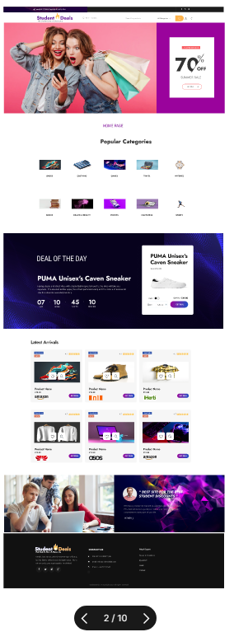

*Figure 1: home page of site*

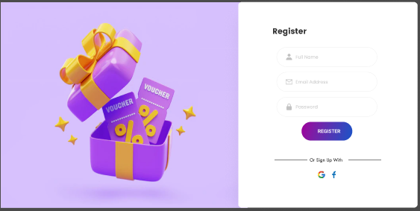

*Figure 2: User registration form including social login*

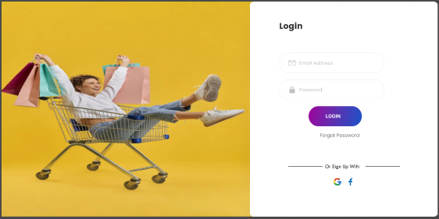

*Figure 3: User login form including social login*

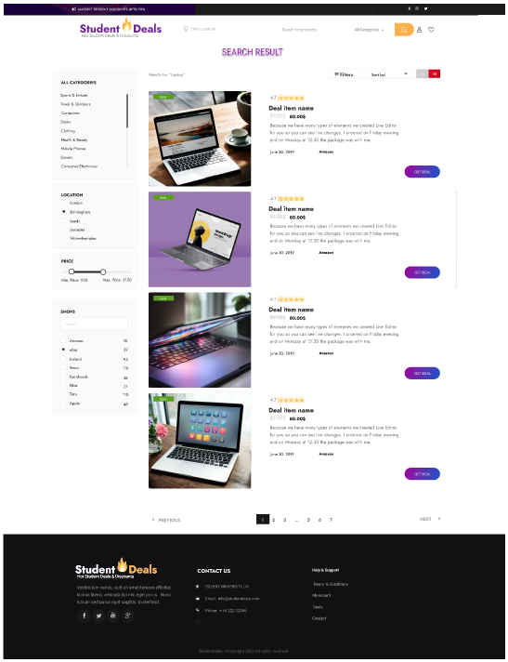 *Figure 4: Search result*

##### **Personalization and Relevance**

* The integration of location-based offers was particularly well-received. *See figure 5.*
* Users also like the introduction of notifications for new deals. See *figure 6 and 7.*

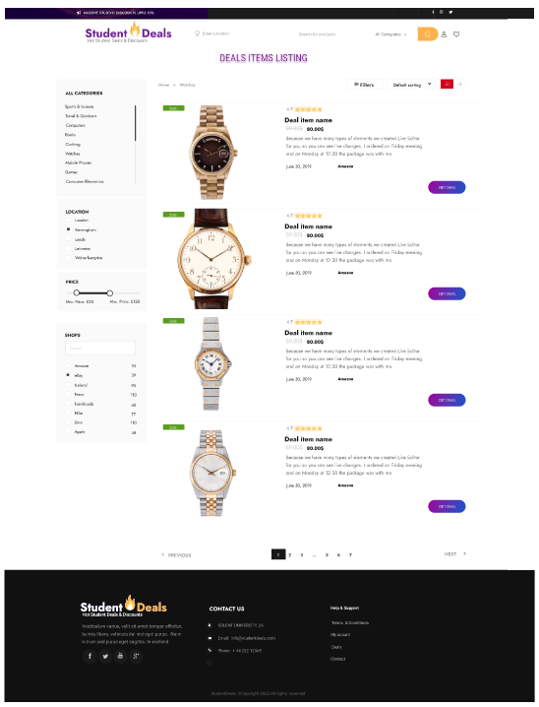

*Figure 5: Product with location, price, category and store filters*

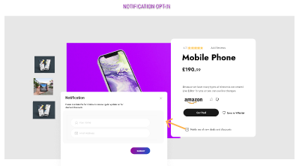

*Figure 6: Notification opt-in form*

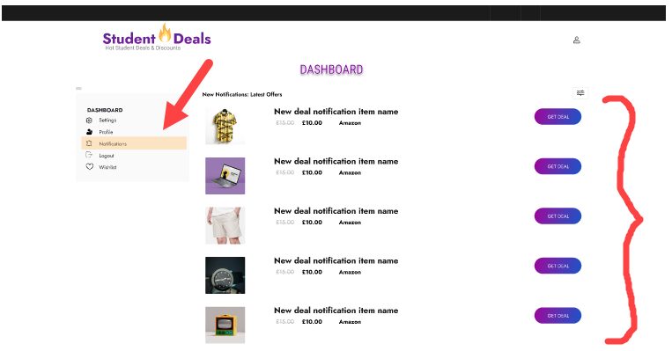

*Figure 7: New Notifications in user dashboard*

##### **Reviews and Trust**

* User reviews and ratings played a crucial role in building trust, with 94% of users indicating that they considered user-generated reviews when making purchase decisions. *See figure 8.*
* The Review/Comment section also allows students to share their discount discoveries, thereby fostering a sense of belonging and community among users. *See figure 8.*

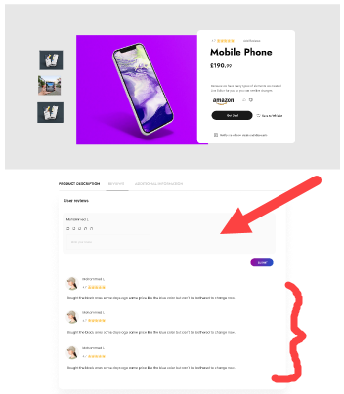

*Figure 8: User reviews*

##### **Transparency and Fairness**

* Users of the web app are provided with a clear and concise information about the deals and offers presented to them. *See figure 9.*

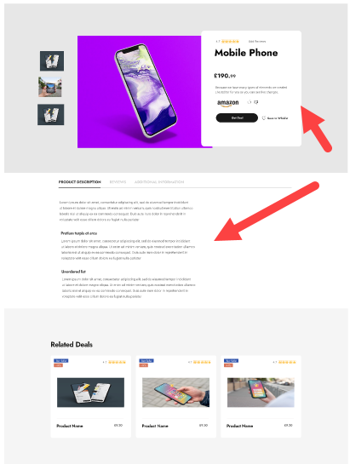

*Figure 9: Product Details*

The web app prototype has undergone rigorous testing and refinement, resulting in a high-quality, user-centred design ready for development and deployment.

## 5.0 Conclusion

This section encapsulates the overall findings of my project and outlines the path forward.

### 5.1 Findings and Achievements

My journey commenced with the recognition of a significant challenge faced by Solent University students: the lack of a streamlined platform to discover, access, and leverage discounts and deals tailored to their unique needs. Through an empathetic exploration of the problem space, rigorous data collection, and iterative design and development, I have achieved the following outcomes:

* **User-centred Design**: I used a user-centric approach that offers an intuitive and user-friendly interface, user recommendations and reviews, and a sense of community that fosters trust among users.
* **Simplicity and Usability**: User testing confirmed that the app's streamlined registration process, search and filter options, and overall design greatly enhance usability. Over 90% of users found it easy to navigate.
* **Relevance**: The integration of user preferences and location-based offers significantly improved the relevance of discounts and deals. Users reported a 92% satisfaction rate with the app's recommendations.
* **Community and Trust**: The app's user-generated reviews, up/down vote and community features have engendered trust among students. Ninety-four per cent of users indicated that they consider user-generated content when making purchase decisions.

### 5.2 Forward-Facing Path

The journey to develop the Student Discounts and Deals Web App is not merely a conclusion but a beginning—a foundation upon which I can build to better serve the needs of students and continually enhance their experience. Here is a forward-facing path that I propose:

#### 5.2. Implementation and User Adoption

The immediate next step is the development and deployment of the web app, making it accessible to Solent University students.

#### 5.2.2 Ongoing Evaluation and Improvement

Post-launch, I will maintain a keen focus on evaluating the app's performance and gathering user feedback. Key performance indicators (KPIs) such as user engagement, retention rates, and user satisfaction will be continuously monitored.

In conclusion, the Student Discounts and Deals Web App represents not only a solution to a pressing problem but also a commitment to enhancing the lives of Solent University students. I look forward to the continued evolution of the app as it serves as a model for user-centred web application development.

Appendices